UCI Beall Center for Art + Technology Celebrates 25 Years of Innovation at the Intersection of Art and Science
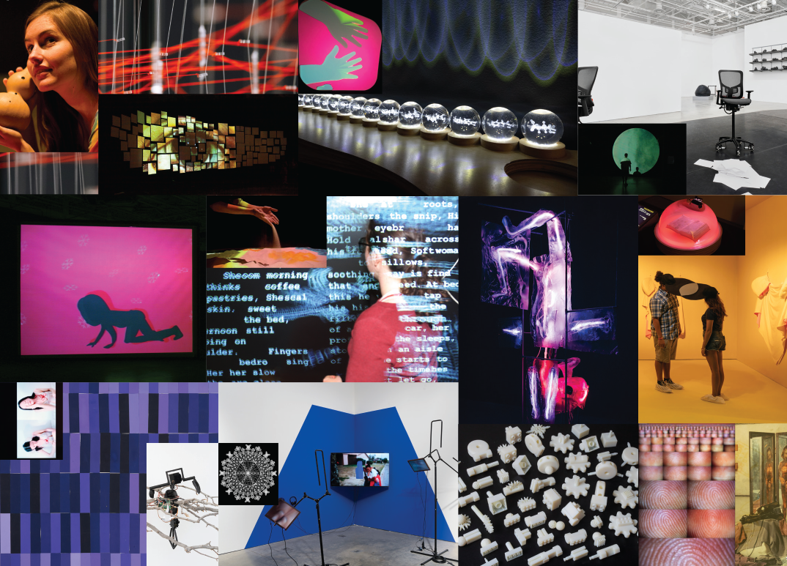
On View: September 13 to October 11, 2025, at UCI and
October 26 to December 28, 2025, at Great Park Gallery, Irvine

IRVINE, Calif. (Date) — In 2025, the Beall Center for Art + Technology at the University of California, Irvine, marks its 25th anniversary as a leading venue for experimental media arts. This milestone year honors a legacy of groundbreaking exhibitions, community engagement and interdisciplinary collaboration that continues to shape the future of contemporary art and digital culture. A year of celebratory events will open with 25 Years at the Beall Center for Art + Technology, curated by artistic director David Familian and former assistant curator Gabriel Tolson. The exhibition opens on Saturday, September 13, 2025, and will run through October 11, 2025, at the UCI Arts campus. The exhibition will also be displayed at the City of Irvine’s Great Park Gallery, located in its Palm Courts Arts Complex from October 26, 2025, to December 28, 2025. Both opening receptions and admission are open and free to the public.

“The 25th anniversary is an auspicious occasion to celebrate that we are among the few spaces specifically dedicated to digital media art in the U.S.,” said Familian. “It’s been a privilege to work here for 20 years, curating solo exhibitions of artists that use computational media and thematic group shows that often address the impact of technology on society. We are proud to highlight experimental, challenging practices that are not widely represented in other university galleries or mainstream museums.”

25 Years at the Beall Center for Art + Technology offers a retrospective look at the center’s rich exhibition history and signature artist residency program. Highlighting its wide-ranging and interdisciplinary explorations of emerging technologies, a comprehensive timeline is illustrated through nine thematic lenses: BioArt, Complex Systems, Data & Research, Games & Narrative, Identity, Interactivity, Robotics, Sounds & Scores and Video. Its inaugural exhibition, SHIFT-CTRL (2000), offered a distinctive take on gaming-related research, examining — critically yet playfully — how gaming has reshaped social systems and creative practices. Subsequent exhibitions such as Live (2008), DataViz (2012), WetWare (2016) and Future Tense (2024) have deepened this critical inquiry into the complex — and often adverse — impacts of technological innovation on society and everyday life. For artists, the Beall Center serves as a proving ground — a place between the artist’s studio and the art museum — and allows them to work with new technologies in their early stages of development. From Katherine Behar’s first solo exhibition Katherine Behar: Ack! Knowledge! Work! (2024) to the first U.S. presentation of drawings by Vera Molnár (1924–2023) Vera Molnár: Variations (2022), the center’s curatorial focus is a diverse range of innovative, world-renowned artists, both national and international, who work with experimental and interactive media. For visitors, the Beall Center serves as a window to some of the most creative visual arts innovations.

The Beall Center received its initial support from the Rockwell Corporation in honor of retired chairman Donald R. Beall and his wife, Joan – the core idea being to merge their lifelong passions of business, engineering, and the arts in one place. Currently chairman of The Beall Family Foundation and a principal in Dartbrook Partners LLC, Donald Beall retired from Rockwell International in 1998 after a 30-year career, during which he served as either chairman/CEO or president/chief operating officer for 20 years. To date, the Beall family’s philanthropic giving to the university totals nearly 30 million.

"Thanks to Don and Joan's visionary gift, the Beall Center has achieved international eminence in presenting artists, designers, and collectives who use technology to explore both the creative opportunities and the urgent issues of our time,” said Jesse Colin Jackson, Executive Director Beall Center for Art + Technology. “As we turn 25, we are thrilled to be celebrating our many achievements.”

25 Years at the Beall Center for Art + Technology will be on view from Saturday, September 13, 2025, through October 11, 2025. The opening reception will take place on Saturday, September 13, from 2 p.m. to 5 p.m. at UCI Arts campus, and the opening at Great Park Gallery will take place on Sunday, October 26, from 1 p.m. to 3 p.m. A 25th Year Anniversary panel discussion will take place on Saturday, October 11, from noon to 2 p.m. at the Beall Center. All events are open and free admission.

25 Years at the Beall Center for Art + Technology is supported by The Beall Family Foundation and the Claire Trevor School of the Arts.

Photo courtesy of UCI Beall Center for Art + Technology. Exhibition design by Becca Lofchie Studio.
###
About the Curators

David Familian
David Familian began working at the Beall Center for Art + Technology in 2005 and was appointed as associate director in April 2006. An artist and educator, he received his B.F.A. from California Institute of the Arts in 1979 and his M.F.A. from UCLA in 1986. For the past 20 years, he taught studio art and critical theory in art schools and universities, including Otis College of Art and Design, Minneapolis College of Art and Design, Santa Clara University, San Francisco Art Institute and U.C. Irvine. Although Familian began his career as a photographer, since 1990, new media has become integral to his own artistic practice and his work as a web producer and technical advisor for individual artists, museums and universities such as Walker Art Center, University of Minnesota and the Orange County Museum of Art. He has curated and organized the majority of exhibitions at the Beall Center. In 2013, he premiered Echo and Narcissus, a new sound video installation with interactive elements at the Art/Sci Gallery at UCLA. Familian developed the Black Box Projects at the Beall Center and meets regularly with artists, as well as technologists and scientists, to collaborate on new projects.

Gabriel Tolson
Gabriel Tolson holds a B.F.A. from the University of Southern California’s School of Art and Design. With a growing focus on climate justice and environmental advocacy, he currently serves as an environmental policy associate at the Planning and Conservation League, where he supports legislative strategies and policy research aimed at advancing sustainable development in California. He also contributes to systems-based environmental analysis as a Policy Researcher at Metabolic Studio and supports grassroots advocacy efforts as a policy and legislative intern at Climate Action California. Before his policy work, Tolson served as a curatorial assistant for the Pacific Standard Time exhibitions Future Tense: Art, Complexity, and Uncertainty at UCI’s Beall Center for Art + Technology and Atmosphere of Sound: Sonic Art in Times of Climate Disruption at UCLA’s Art|Sci Center, where he explored the intersections of art, technology and ecological awareness.

About the Claire Trevor School of the Arts
As UCI’s creative engine, the Claire Trevor School of the Arts (UCI Arts) has proven itself to be a national leader in training future generations of artists and scholars who go on to inspire audiences in theaters, galleries and concert halls – as well as in entertainment and technology-related venues throughout the world. UCI Arts combines artistic training with a top-ranked liberal arts education. It is home to the departments of art, dance, drama and music, offering 15 undergraduate and graduate degree programs and two minors. UCI Arts is currently ranked No. 1 in affordable fine arts, drama/theater, and music degrees by the College Affordability Guide. Courses include extensive studio, workshop, and performance experiences; theoretical and historical studies; and arts and technology practices. UCI Art’s nationally ranked programs begin with training but culminate in original 5 invention. The distinguished, international faculty work across a wide variety of art forms and forge interdisciplinary partnerships with others across the campus. For more information, visit www.arts.uci.edu.

IMAGES

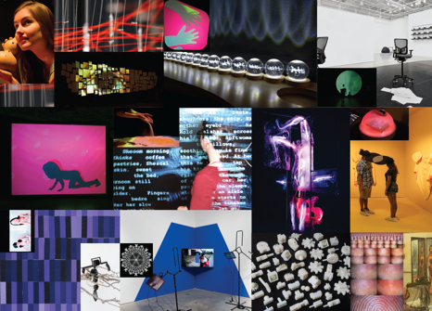 | Various installations at UCI Beall Center for Art + Technology 2000–2024. Photo courtesy of UCI Beall Center for Art + Technology.  Image file
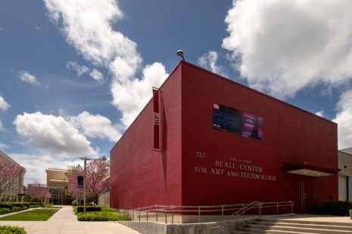 | Beall Center for Art + Technology, 2023.  Photo by Steve Zylius, courtesy of UCI.  [Image file]
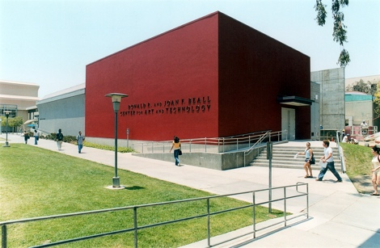 | Beall Center for Art + Technology, circa 2000.  Photo by RSR Productions, courtesy of UCI.  [Image file]

